**Expeiment-9**

**AIM:**

To implement the following Transform methods

a.Uniform Discretization Transform

Data Set: sonar.csv

**SOFWARE**:

Python IDE

**THEORY:**

Discretization is the process through which we can transform continuous variables, models or functions into a discrete form. We do this by creating a set of contiguous intervals (or bins) that go across the range of our desired variable/model/function.

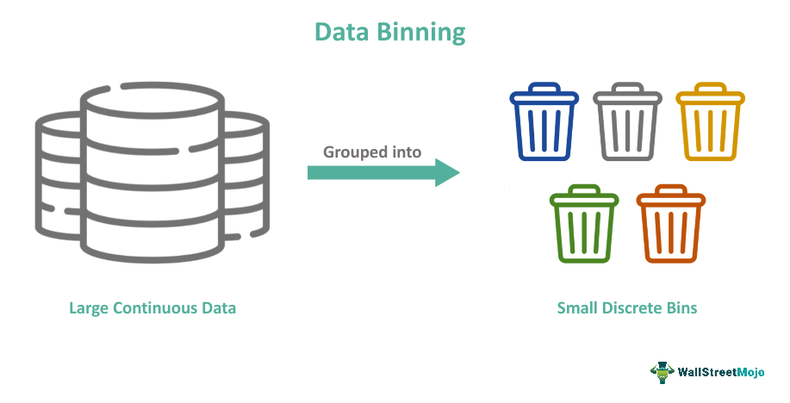

**CODE:**

# visualize a uniform ordinal discretization transform of the sonar dataset

from pandas import read_csv

from pandas import DataFrame

from pandas.plotting import scatter_matrix

from sklearn.preprocessing import KBinsDiscretizer

from matplotlib import pyplot

# load dataset

url = "https://raw.githubusercontent.com/jbrownlee/Datasets/master/sonar.csv"

dataset = read_csv(url, header=None)

# retrieve just the numeric input values

data = dataset.values[:, :-1]

# perform a uniform discretization transform of the dataset

trans = KBinsDiscretizer(n_bins=10, encode='ordinal', strategy='uniform')

data = trans.fit_transform(data)

# convert the array back to a dataframe

dataset = DataFrame(data)

# histograms of the variables

dataset.hist()

pyplot.show()

**RESULT :** Uniform Discretization Transform was implemented on Data Set: sonar.csv